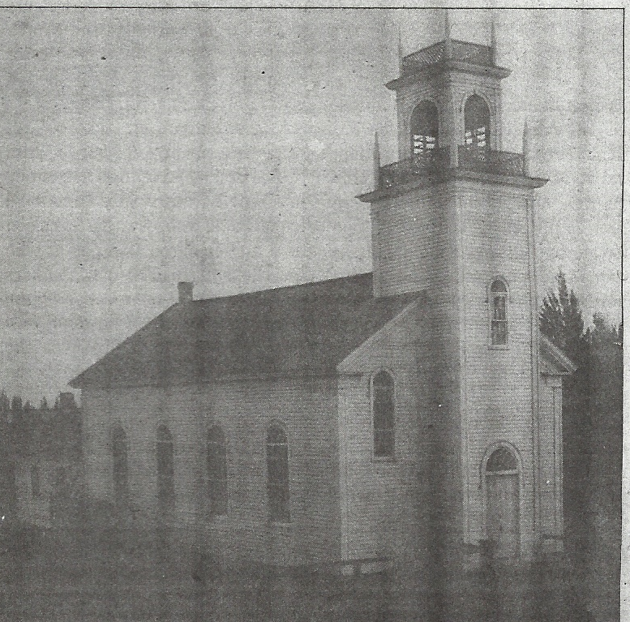
Introduction
When a Christian congregation has experienced the visible blessings of our merciful God for several years, it is certainly meet and right for such congregation to remember those bountiful blessings and come before the countenance of God with gratitude and devout thanksgiving.
Beginning with the 1860’s – German immigrants came from northeastern Germany, presently part of eastern Germany and Poland. They found their way to northeastern Wisconsin to that part of the Fox River Valley which would become the village of Wrightstown. Most of the founders were thus Baltic Germans who came from the states of Pomerania, Posen, Mecklenburg – Schwerin, and west Prussia. The introduction of conscription throughout the newly unified German Empire only gave impetus to the immigration.
The Baltic Germans, who settled in the Fox River Valley, were Lutheran and wanted to duplicate the religious and community life they had left behind. This meant the founding of churches, schools, and social organizations.
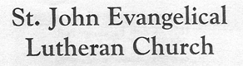

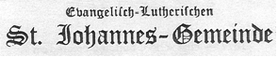
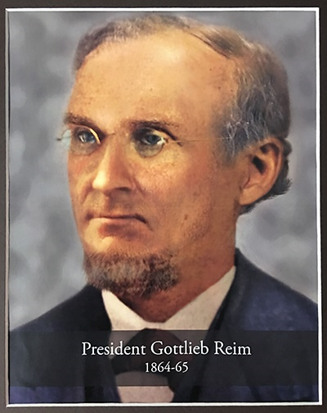
History of St. John Ev. Lutheran Congregation
Sometime in the year 1869 the Reverend E. G. Reim came to Wrightstown from Green Bay to preach the Word of God and to administer the sacraments to Lutheran people reported to be living in this area. According to God’s promise, his labors were successful. So much so, in fact, that a congregation was organized that same year. The organizing members chose to name the newly-formed congregation after St. John, the disciple and apostle of love, indicating that the love of god as shown to John and proclaimed by him was to be the guiding principle of its members for all time. This chosen name is always worthy of study and remembrance.
No written list of the organizers was found, but according to the recollection of some older members with good memories, there were 18 names on the list:
John Gabler Ferdinand Reschke John Tetzlaff
Wilhelm Krueger Wilhelm Ristow Frederick Werner
August Kuehn Nicholas Schmidt Wilhelm Zimmermann
Ferdinand Maass August Schroeder Christian Zittlow
Carl Mueller Carl Schroeder Frank Zittlow
Rudolph Pflueger August Tetzlaff Gottfreid Zittlow

This small group appreciated hearing the precious Word of God and wanted to assure themselves of this continued privilege. Thus, they decided to build a church and to call a pastor. The First Constitution of the “Evangliche Lutherische St. Johannes Gemeinde” was signed by forty-seven heads of families on May 4th, 1869. On lots donated by Carl Mueller, one of the founders of the congregation, the first church was erected, and it was dedicated Christmas Day 1869. This church served the congregation’s needs until 1911.
The natural next step was taken the following year when the congregation built its first parsonage. It seems the members were in hopes that Pastor Reim of Green Bay would be their first resident pastor. When these hopes were not realized, the voters sent a call to Pastor W. G. Haack, in 1870, who accepted and became the first Lutheran minister to live in Wrightstown. Since pastors were not too plentiful in those days, Pastor Haack also served the congregations in De Pere and the Town of Woodville.
Already in 1871, a small addition was added to the rear of the church to provide a place for the pastor to begin a Christian Day School.
Two years after that the congregation purchased land from Nicholas Schmidt to be used as a parish cemetery.
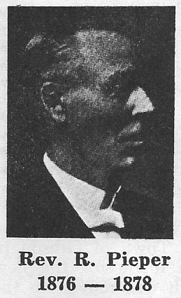
After two years of service here Pastor Haack was granted a release to accept another call. After leaving in October 1873, he was followed by Pastors K. Havener (sometimes listed as Huebner) and Frederick Schugh until March 1, 1876.
The next pastor was the Reverend Reinhold Pieper. He also served the congregations in De Pere and Town of Woodville and in 1877 organized Trinity Lutheran congregation in Kaukauna.
In that same year, the first school building was erected by the congregation on a parcel of land donated by Mr. Carl Mueller, who had previously given the lots on which the church and parsonage were erected. When the new school building was completed in 1948, this yellow brick structure was sold. It can still be seen on High Street.
When Pastor Pieper left to accept a call from the First German Lutheran congregation at Manitowoc in 1878, he was replaced by Pastor William Bergholz. He also served here for only about two years, and then the congregation was without a resident pastor for almost a year. Finally, the Lord supplied the congregation’s need in the person of the Reverend Christian Popp, who labored here faithfully for 19 years until age and health forced him to resign. During this pastorate the congregation became an official member of the church body currently known as the Wisconsin Evangelical Lutheran Synod (WELS). The church property was also enlarged during his years with a purchase of extra land from Frank Zittlow in 1882. Almost two years later a fervent wish of the members was fulfilled when a bell was purchased and hung in the steeple through funds furnished largely by the young people. This bell was later rehung in the tower of the new church building, erected in 1911, and still serves to announce to the members and to others that the Lord is in his holy temple and all the world should keep silence before him.
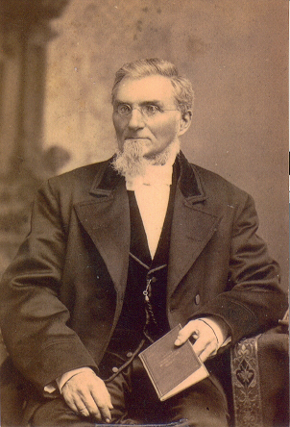
Pastor Popp was known as a man who had the Christian education of the children at heart and labored faithfully for the parochial school, either doing the teaching himself, or paying someone to teach in his place, out of his own income. He preached his farewell sermon on Sunday, June 24, 1900, and retired after fifty years of service in the Lord’s vineyard.
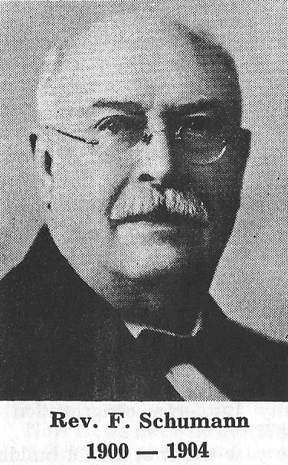
Pastor F. Schumann then accepted the call to serve this congregation and did so with great zeal and devotion, also devoting much time to Christian education until he accepted an urgent call to Sturgeon Bay (then known as Sawyer), Wisconsin in the fall of the year 1904.
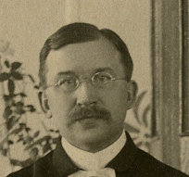
Pastor C. Auerswald became his successor. During his ministry the congregation engaged a teacher for the school for the first time, permitting him to devote more of his time to the many duties involved in the pastoral office.
It was during his pastorate that the Ladies’ Aid Society was organized on January 21, 1906. In the same year a number of members were led to establish a new congregation in Greenleaf. For a time, Pastor Auerswald served both congregations until the St. Paul congregation called its own pastor. On March 1, 1910 the decision was made to erect a new church edifice that would more effectively serve the needs of the membership, but before this decision was put into effect, Pastor Auerswald left Wrightstown for Slinger, Wisconsin (at that time called Schlesingerville).
By this time one of the purposes of the Christian Day School, the preservation of German language and culture, had diminished in the minds of many as they saw their children increasingly Americanized. This generation began to view the cost of operating the school as a burden too great to bear; the school was closed in 1910.
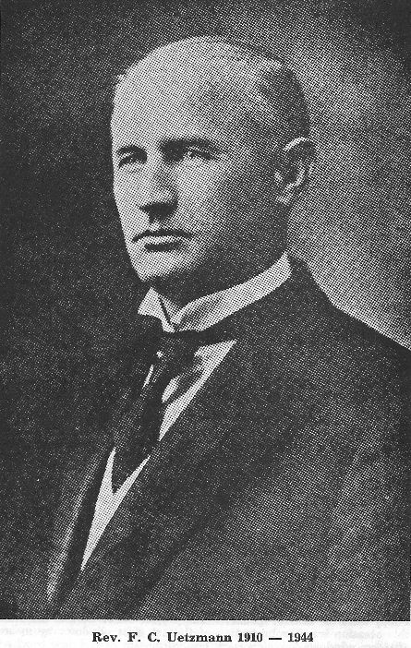
Pastor Auerswald’s successor was Pastor F. C. Uetzmann, who was installed on November 6, 1910, having come here from the Town of Gibson in Manitowoc County. (Pastor Uetzmann was born in Germany and came to this country with his parents when he was seven months old.) Zealous preparations were made for the new house of God that same winter. The old church was moved to the rear of the church property so that the new edifice could be erected on the same spot where the first church had stood.
The plans for the new church were drawn by Mr. W. Delong of Appleton, Wisconsin; the contract work for the new building was left to Gustave Fleck of De Pere, Wisconsin; the building committee chosen to oversee the project consisted of the Messrs. Otto Kuehn, Michael Meyer, Albert Rather, J.W. Zimmermann, and the pastor, F. C. Uetzmann. The cornerstone was laid on May 28, 1911.
On February 11, 1912 the new house of worship was dedicated to the service of the triune God. The morning service started in the old church building with a hymn and speech. Then all congregants walked to the new church where hymns were sung in German by the congregation and choir. The sermon, also in German, was given by Professor J. Schaller from the Lutheran Seminary in Wauwatosa, Wisconsin using Luke 19: 1-10 as the theme.
An afternoon German service was held, and an evening English service was held with the sermon given by Rev. E. C. Hinnenthal of Forestville, Wisconsin.
It certainly seems astounding to us that this building, still in use at our sesquicentennial, could be built for approximately $18,000 and was fully paid for in the short space of three years, with some money still left in the treasury.
The joy the members experienced in erecting and dedicating a new house of worship seemingly was so great that they felt that with the Lord’s help they could do more to glorify the God of all mercy and grace. Accordingly, they decided to also build a new parsonage. A building committee consisting of Albert Rather, William Spietz, and Otto Zirbel awarded the contract to Mr. Charles Kussow. This structure was dedicated to the same God of all grace November 22, 1914. Two years later the treasurer, Ferdinand Just, reported that the parsonage was also fully the congregation’s own.
The year 1919 marked the golden jubilee year of the congregation. This occasion was celebrated by a special service held on December 28, 1919 to offer special praise and thanksgiving to almighty God for His abundant blessing during a half century.
Plans had been made to purchase a pipe organ for the church and dedicate it to the service of our gracious Lord in the golden jubilee service. When the organ did not arrive in time, these plans could not be realized, but it was finally installed and set apart for the Lord’s glory on September 26, 1920. The total cost of the organ was $3,320. That, too, was paid for in two years’ time with assistance from the Ladies’ Aid Society and the Young People’s Society.
Being blessed by God in many ways and being constantly nourished spiritually by Him, the members of the congregation were ever alert for celebrating some event. Hence, they joined the Fox River Valley Pastoral Conference in observing the 25th anniversary of Pastor Uetzmann’s service to God in the preaching ministry on April 11, 1923 and followed this with a surprise celebration of his and Mrs. Uetzmann’s silver wedding anniversary.
This did not mean that during this time the church itself was forgotten. The Ladies’ Aid Society beautified the altar with two electric candelabra.
The sixtieth anniversary of the congregation’s history was specially observed on September 8, 1929.
Eight years later a new heating plant was installed in the church by Frank P. Falck and Sons of Morrison which included a stoker and blower attachment. This was two years after a new furnace had been installed in the parsonage basement by the same company.
After the new church building had stood and served the members for a period of 25 years, it was decided to have it redecorated. The work was done by Fred C. Ott of Marinette, Wisconsin. When the work was completed, the 25th anniversary of the dedication was observed in a special service on October 10, 1937. To add further beauty to the house of God, the young people of the congregation with assistance from the Needle Club and the choir had electric lights installed. These lights are still serving us today. These groups were joined by the Ladies’ Aid, which had carpeting laid on the altar platform and the floor in front of the altar steps.
Finally, the year 1944 marked the 75th anniversary of the St. John Congregation’s history. This was duly observed with three services, morning, afternoon, and evening on September 3. Pastor E. G. Behm of Calvary, Wisconsin, Pastor W. G. Haase of Two Rivers, Wisconsin, and Pastor R. J. Pope (grandson of the former Pastor Popp) were the festival speakers. The project undertaken to celebrate this occasion was the protection of the art glass windows by means of storm windows.
Late in the fall of 1944 Pastor Uetzmann’s long service to the congregation ended when he accepted a call to a small congregation near Ixonia, Wisconsin. It was there that he celebrated the 50th anniversary of his service to the Lord in the holy ministry. Somewhat later he retired and spent his remaining days and years in Watertown, Wisconsin. He should still be remembered by some members of our congregation for his almost 35 years as pastor here, most of which were marked with a meager income.
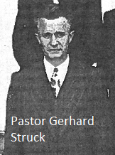
Within about a month the congregation was supplied with a new pastor in the person of Gerhard Struck, who came from St. John Lutheran Church in Maribel, Wisconsin. (Pastor Gerhard Struck was born in Bad Pyrmont, Germany in 1908. He came to the United States with his parents in 1914 at the age of 6.) Rev. Melvin Croll assisted by Rev. A. F. Herzfeldt officiated at the installation ceremony on Sunday evening January 7, 1945 at 7:30 pm. It was under his pastorate that Christian education was revived to the extent that the school was reopened in 1945 with a greater enrollment than had been anticipated. At first, the old one-room school building was used by two teachers. Then the new principal, Mr. Gerhard Koepsell, moved with his classes into the church basement until the new school building was completed and dedicated in 1948.
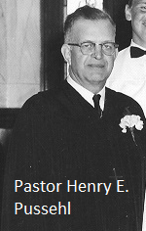
In November of 1950 the congregation was again without a resident pastor when Pastor Struck left to serve a congregation at Dowagiac, Michigan. The vacancy lasted until the following April when Pastor Henry E. Pussehl was installed by Pastor Melvin Croll of Greenleaf, who had served as vacancy pastor assisted by Pastor August Herzfeldt of Appleton.
In July of that same year an option was taken on the dwelling next to the parsonage in the hope that it might serve as a home for our school principal. Later that same year, the home was bought, remodeled and reroofed at some expense. Within a month’s time it was reported that over $3,000 had been contributed toward its purchase. (This building was later sold in 2009.)
On August 31, 1958 the tenth anniversary of the erection of the new school building was observed with two services at which the former pastor, Gerhard Struck, then of Bay City, Michigan, and Professor Elmer Kiessling of Northwestern College in Watertown, Wisconsin were the festival speakers. A reunion of former graduates and students of the school was also held that day.
On November 23 of the same year the congregation surprised Pastor Pussehl with a celebration of his 25th anniversary in the ministry. Professor Carl Lawrence, President of our Wisconsin Lutheran Seminary at Thiensville, Wisconsin, was engaged to preach the sermon for this occasion.
On Sunday, June 21, 1959, the 90th Anniversary of the congregation’s existence was observed with three festival services.
Pastor Henry Rosin of Peridot, Arizona, delivered the morning anniversary sermon. Pastor Rosin was a son of this congregation who spent more than 50 years of his ministry as a missionary of the Wisconsin Synod among the Apache Indians in Arizona.
Pastor Hogey Bergholz, an instructor at Fox Valley Lutheran High School in Appleton, and a grandson of a former pastor of the congregation, the Rev. William Bergholz, delivered the afternoon anniversary sermon.
Pastor Immanuel Uetzmann of Watertown, Wis., a son of the late Pastor F. C. Uetzmann, who served as pastor at Wrightstown for 34 years, delivered the evening anniversary sermon.
June 24, 1962 was the next day of celebration. This was for the 50th anniversary of the dedication of the second church building. Pastors I.G. Uetzmann of Watertown, Wisconsin, Melvin Croll of Kekoskee, Wisconsin, and Erwin Ploetz of Dale, Wisconsin encouraged the members to never forget to give thanks to the Lord for the blessed truths heard in this building for a half century.
Over the years various repairs and improvements had to be made to the property of the congregation. However, much greater interest began to be taken as the members became aware that the congregation was nearing the one hundredth anniversary of its founding. In preparation for this, an anniversary committee was chosen to make plans and preparations for this grand occasion and for the glorification of the Lord who had so mercifully and graciously upheld and protected that to which he had given birth a century previously.
The plans developed by this committee and accepted by the congregation were to put new carpeting in the church, covering the entire altar platform and the floor up to the front pews and up the three aisles, install new pews, and redecorate the church. The carpeting was laid by Christmas time in 1968. The new pews were ready for installation a year later, but the installation was postponed until the decorating was done late in 1969. The decorating was in the hands of J. J. Stradel of Wayside, Wisconsin and the pews were installed by members after they were shipped by the Manitowoc Church Furniture Company of Waukesha, Wisconsin.
Members of St. John felt themselves blessed by the lord in many ways as they prepared for this centennial celebration and showed it by contributions that made possible the beautifying once again of the house of the Lord in which they heard His saving Word. Practically all the pews were given as memorials and other donations for improvement of the church building upstairs and down were received in thanksgiving to God for His abounding mercy. As an added feature, the Ladies’ Aid Society had reached a decision to add chimes to the organ, which was undergoing remodeling and rebuilding, but which could not be finished before the first celebration day of June 7, 1970.
A second centennial celebration day was held on June 14, 1970. There were two services that day: A divine anniversary service in the morning where seminary student, Gerhard Schopekahm, was in charge. The sermon during that service was given by Pastor Henry Rosin of San Carlos, Arizona.
The second service was at 2:30 p.m. and again had Gerhard Schopekahm in charge. The sermon was given by seminary student Paul Zittlow of Kaukauna, Wisconsin. An interesting note: the organist for both services was Mr. George Lillegard.
A whole century of history had passed by the grace of God. We cannot forget that he led many sons of the congregation to enter the preaching ministry to bring the Word of Life to others: Henry Rosin, Theophil Uetzmann, Immanual Uetzmann, Paul Zittlow, Richard Scheibe, and Gerhard Schopekahm (a teacher at the school from 1954 to 1959).
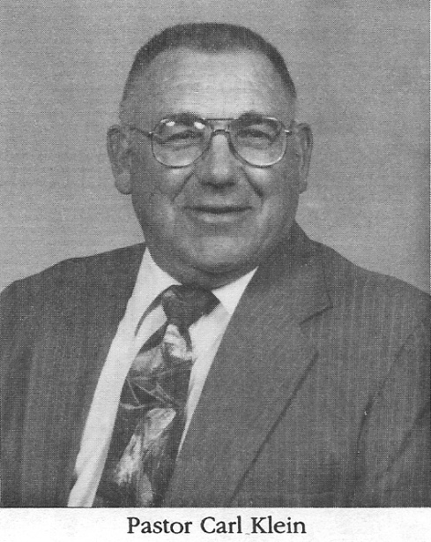
In 1975, Pastor Henry Pussehl decided to retire after 24 years of service to the congregation. A call was placed to Pastor Carl Klein, who came to Wrightstown after having served St. Paul in Gladstone, Michigan and St. Martin in Rapid River, Michigan. Under Pastor Klein’s leadership the Sunday school was re-established. Pastor Klein also urged that church members be more active in pursuing God’s work in this world. Church activities increased dramatically and can be traced through changes in the governance structure: A stewardship committee was formed to oversee various church activities; an evangelism committee was formed to spread the Gospel to the unchurched of the community; and an endowment committee was organized to build an endowment for the congregation. Church elders and trustees began to meet separately to oversee the direction of the congregation and collectively in the Church Council.
The expansion of church activities would also lead to structural changes in the church itself. The congregation needed meetings rooms, a proper office for the pastor, and a fellowship hall. There was need to improve access for the handicapped. The handsome edifice which had served its members so well had also begun to show its age. A small problem here, another problem there, a leaky roof, a furnace that only worked well during the summer, moisture problems in the basement and a variety of other things needed improvement in our church building. By the early 1980’s, so much repair and renovation were needed and the costs so great that members began to consider whether it might be simpler to construct a new church. This was a bold new thought and as one might expect was quite controversial.
In 1982, a committee formed to investigate the cost of building a new church and to get cost estimates on needed repairs. This church building study committee gave its report to a voters’ meeting held on November 15, 1982. The members took no immediate action but decided to solicit opinions from the entire congregation. In April 1983 the congregation established a church building or repair fund. The committee continued to advertise for proposals to construct a new building or to repair the existing building.
On September 14, 1983 voters met to decide whether to build a new church or renovate the existing structure. After much discussion, the members voted to renovate the historic landmark. The church building study committee expanded to become the church building committee, with authority to supervise the work.
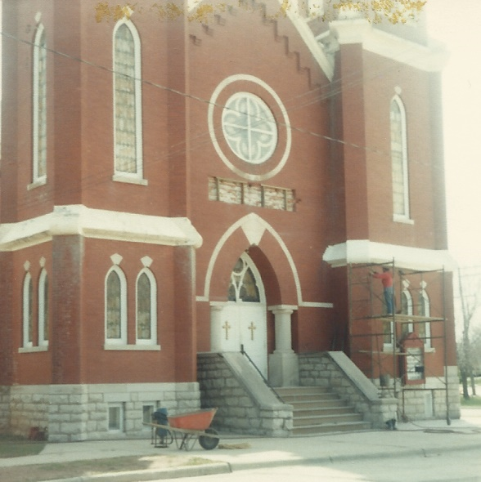
Church members immediately began work on the church heating system. The work was completed just before Christmas of 1983. Contractors were hired to repair the roof and do needed tuck pointing. In 1984 the state approved plans for the front of the church. The church then hired a contractor to do the work.
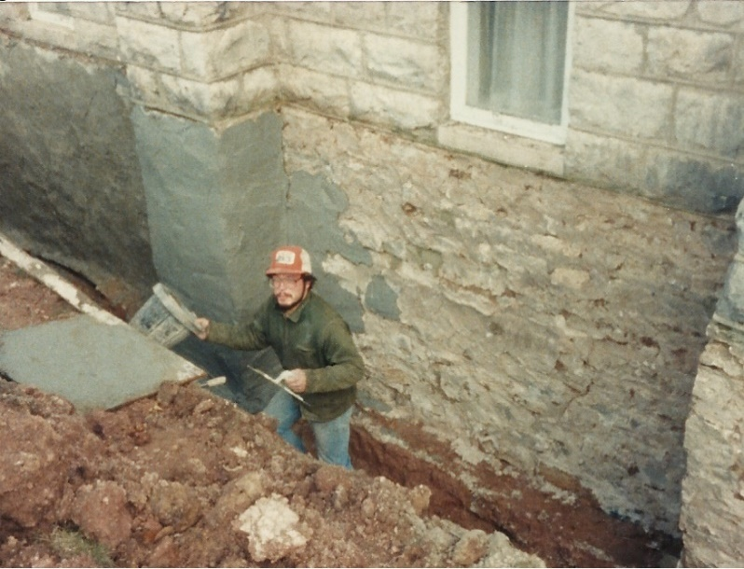
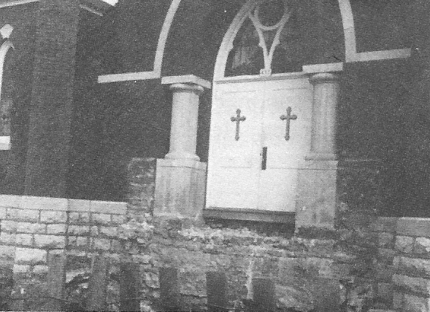

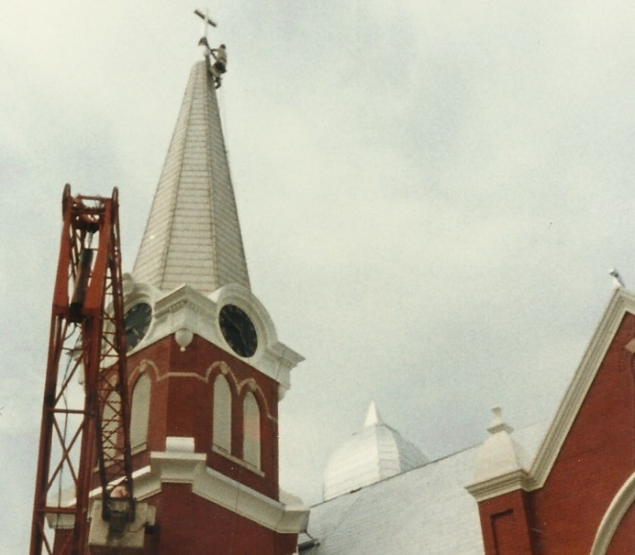
Because of all the improvements and restoring of our church exterior many members started looking at the church and thinking of what else needed improvement. As we look at the men working on the windows and bricks and then up to the roof our eyes finally wander heavenward to the steeple and what was once a lighted cross on its peak. Many members wanted the lighted cross restored.
While the work was being done on the outside of church there were many busy men inside. A lot of interior things had to be changed to match the construction that was being done on the outside. The basement of the church was completely redone – bathrooms, carpeting, ceiling lowered, new lighting, new interior walls, new furnace room, and new kitchen. Many faithful members contributed their efforts in these projects.
In July of 1984 we saw ourselves walking over new poured concrete, piles of blocks, sand, and temporary paths to go to church. We knew renovation was in full swing and could see its progress weekly as we attended Sunday services. Another major step was taken in July when approval was given to the Building Committee to obtain plans for an addition to the rear of church.
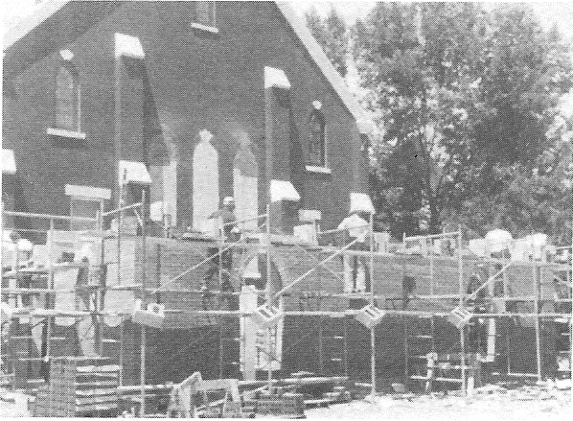
In September, the last major project was approved: to proceed with construction of the rear addition to the church. Although it was voted to proceed in September of 1984, the actual construction did not begin until the spring of 1985. It was decided that the contractor would construct only the shell with the interior work done by congregation members.

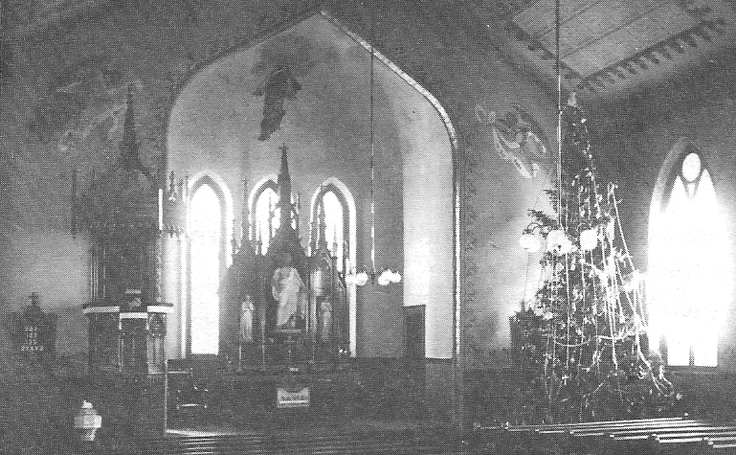
Interior of St. John Over the Years
1914

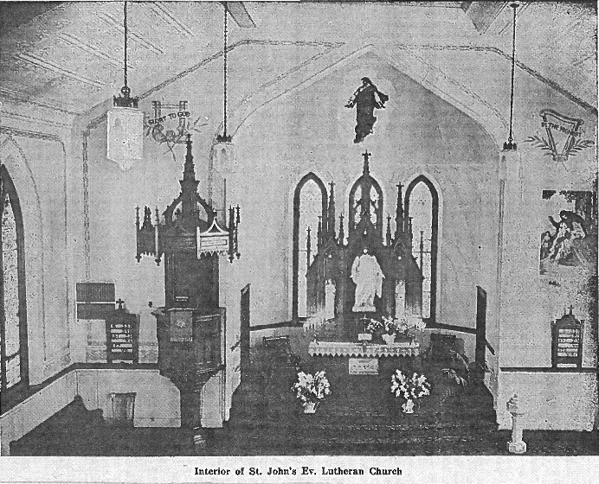
1944

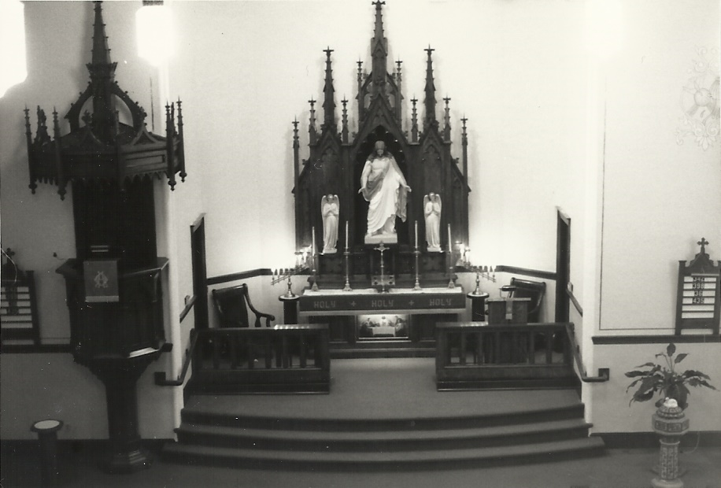
1986

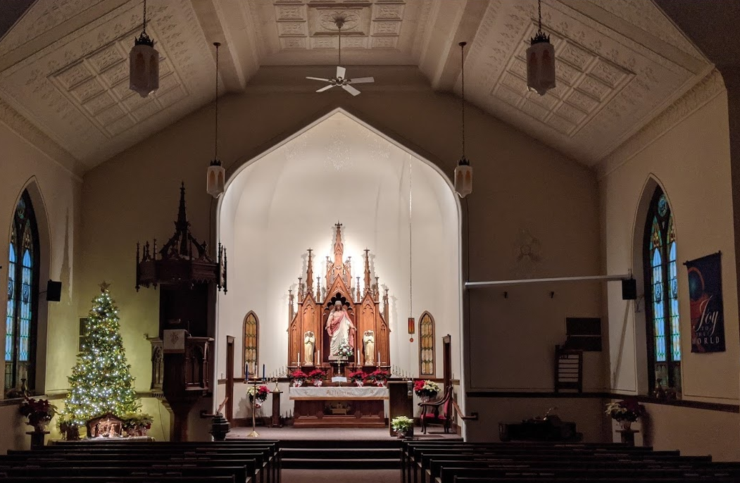
2019

Through much of 1984 and 1985 there was discussion about the clock in the bell tower. Thoughts and emotions went back and forth between repairing the clock or electrifying. In the end, repairing was decided upon.
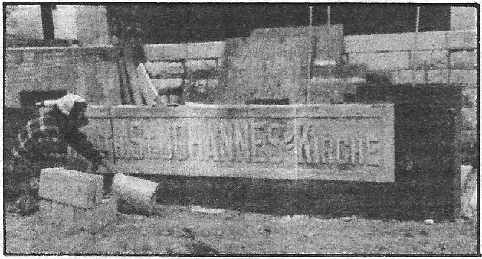
After all the leaks were stopped, windows repaired and much of the construction mess finished, came the last project: the redecorating. After several worship services in our fellowship hall, we could again have services in our church, newly painted with new symbols, pictures, artwork, and new console for the organ.
Thus, came to an end, years of planning, discussing, decision making, meetings, and work called church renovation. It ended with the Day of Rededication on September 21, 1986, with a cornerstone laying service with Pastor Paul Zittlow (Church of the Redeemer, Mandan, ND) preaching. The worship service was presided over by Pastor Richard Scheibe (Atonement, Baltimore, MD). We can celebrate and praise the Lord for what he has accomplished
The 125th Anniversary of the founding of the congregation was celebrated on October 23, 1994. The occasion was marked by two church services with sons of the congregation preaching: Pastors Paul Zittlow and Richard Scheibe.
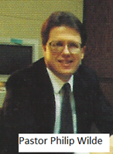
A dinner was given by the Ladies Aid Society following the morning service. Pictures of confirmands starting in the year 1905 prepared by Dorothy Zirbel and Sophia Kussow were on display. To celebrate the occasion the congregation built new garages for the parsonage and teacherage.
In June 1997, Pastor Klein retired from full-time ministry and St. John Congregation issued a call to Pastor Philip Wilde. Pastor Wilde was installed in July 1997.
In 2000 Pastor Wilde resigned his call and the congregation called Pastor Ronald Zindler who was installed in January 2001.
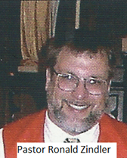
That year the Village of Wrightstown celebrated its 100th anniversary of incorporation. During celebrations historic buildings were opened to visitors for viewing. St. John Ev. Lutheran Church was one of these historic buildings. Guides were available to explain some of the historic features: the gothic style altar and pulpit along with the statues on the altar; two large stained (art glass) windows depicting Jesus with his sheep and knocking at the door; inserts of the windows depicting religious symbols like the Lily, a Christian symbol for the Resurrection and the Fleur De Lis which is a lily and a common Christian symbol for the Trinity; the painted pressed-tin ceiling as part of the original church; and the large round stained-glass window viewed from outside.
In 2002 a two-year study began to assess the ministry and facility needs of the church and school. Both long-standing and recent needs were identified, leading to the establishment of a building committee in January 2005. After concluding that renovation the existing school was too expensive and that the church building was essentially solid, the committee offered the congregation two options: 1) Build a school addition attached to the current church, or 2) Build a new church and school on a new site. In March of 2008 the congregation voted for the second option to be accomplished in stages and authorized the purchase of 21 acres of farmland on Plum Road. In January of the following year the land purchase was completed for $450,000.
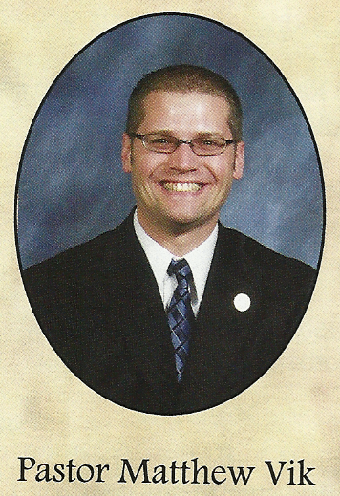
Late in 2008, Pastor Zindler took a call to serve in Michigan. Pastor Klein served as vacancy pastor until the congregation could call a new pastor.
In 2009 after months of trying to call a pastor the congregation turned to the Seminary for a graduate and was assigned Matthew Vik to serve at St. John. On August 2, 2009, St. John held his ordination and installation service with Pastor C. M. Klein as liturgist and Pastor Jeffery Suhr preaching the sermon and performing the rite of ordination. This was the first ordination in the history of the St. John church edifice.
The building committee reconvened to continue ministry and facilities planning. Numerous renovations were made to the church. A projection screen was installed to help the congregation follow the service. The church was air conditioned, and the exterior trim was repainted. In 2012 a sub-altar was constructed and dedicated. Parts of the old communion rail were incorporated into its design. In addition, an early Wednesday morning Bible class at 7 am with breakfast was started.
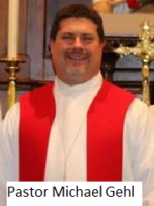
Plans to build were put on hold when in October of 2011 St. John decided to pursue the establishment of a school in cooperation with other WELS congregations. This project, which became known as Foundation Christian Academy, was terminated in May of 2013 when a major participant withdrew its support. Later in 2013 a series of open forums confirmed St. John Congregation’s commitment to its Lutheran Elementary School.
In 2015 Pastor Vik took a call to Fort Atkinson, Wisconsin. The congregation extended a call to Pastor Michael Gehl, who had previously served Grace, Charlotte, NC; Our Savior, Arlington, TX and Victory of the Lamb, Katy, TX. He was installed on January 10, 2016.
In August of 2016 a Long-Range Planning Committee was established to once again analyze the various ministries carried out at St. John, and to make recommendations to the congregation. Early in 2018 St. John resolved that the long list of needs at both the church and school necessitated the construction of a new church, of classrooms for the Lutheran elementary school and Sunday school, and of office and related ancillary spaces – all in Phase I-with a gymnasium and additional classrooms in Phase II. Appropriate committees were then established to carry out this resolution.
On June 9th a special meeting was held after worship to approve recommendations from the Long-Range Planning Committee regarding an architect, builder, and capital campaign manager. One of the LRPC’s recommendations was to add a part-time pastor to the staff to take on various responsibilities, especially in the area of member visitations.
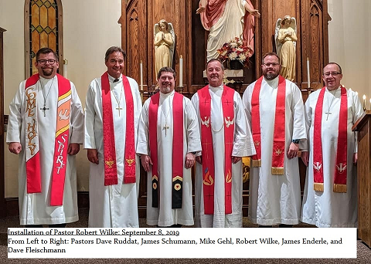
After numerous calls, recently retired Pastor Robert Wilke accepted our call and was installed on September 8th. Pastor Wilke previously served at Shepherd of the Lakes in Fairmont, MN and Zion in Columbus, WI.
The Events Committee organized, prepared, and served the meal to welcome Pastor and Donna Wilke to our church family.
By year’s end, the Building Committee developed detailed plans for constructing our new church and school with much feedback from congregation members.
We realize that our ministry’s focus is on connecting people with God’s Word. Our purpose for existence is to better connect with others so that Jesus Christ is proclaimed, and faith in him is created and strengthened. The reason for the new church and school is to create better opportunities for connecting with people and to better serve the needs of our members.
Four committees were formed: Building, Finance, Property Disposition and Communication. The latter keeps the congregation knowledgeable about specific details as the planning process continues. The Long-Range Planning Committee adopted B.O.L.D S.T.E.P.S as the building project theme. Building On a Legacy Devoted to God and His Word, Sharing the Word, Trusting God for this result, Encouraging each other, Praying for success, and Supporting with our time and resources.
The ultimate goal is to have new buildings that are better tools in sharing Jesus with the Wrightstown Community. Jesus is the foundation of all our earthly decisions, and it should be with him that we begin planning our new facilities.

