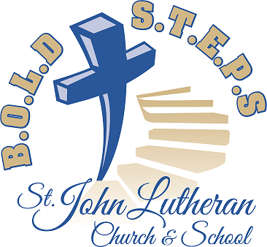
Our B.O.L.D S.t.e.p.s building project took a great leap forward when on June 9 the Voters approved three major recommendations from the Building and Finance Committees.

… that St. John acquire the services of Catalyst Construction of Milwaukee, WI for the building of a new church and school on the Plum Road site.

… that St. John acquire the services of Excel Engineering (Tom Schermerhorn) of Fond du Lac, WI as architect for the building project.

… that St. John acquire the services of Cornerstone Stewardship Ministry (Jeff Davis) of Lake Mills, WI to assist us in the capital campaign.

This action will enable the Building Committee to now proceed in earnest to prepare for you sketches that will enable you to better visualize the scope of the proposed building and to see how it will be situated on the Plum Road site. Furthermore, the Finance Committee will now be able to proceed with the design of a capital fund campaign.

Some might say the site plans and costs should first be determined so that that Finance Committee will know how much must be raised. Others would say we should first determine how much we can raise and then instruct the Building Committee to see what sort of building can be constructed up to that dollar amount. Your Long-Range Planning Committee sees merit in both arguments, and thus expects that both committees will proceed in earnest but also with complete coordination along the way. This is seen as the most efficient way to arrive at a building proposal which meets our needs and yet is within budget.

#6 June 2019
Our B.O.L.D S.t.e.p.s building project took a great leap forward when on June 9 the Voters approved three major recommendations from the Building and Finance Committees.

… that St. John acquire the services of Catalyst Construction of Milwaukee, WI for the building of a new church and school on the Plum Road site.

… that St. John acquire the services of Excel Engineering (Tom Schermerhorn) of Fond du Lac, WI as architect for the building project.

… that St. John acquire the services of Cornerstone Stewardship Ministry (Jeff Davis) of Lake Mills, WI to assist us in the capital campaign.

This action will enable the Building Committee to now proceed in earnest to prepare for you sketches that will enable you to better visualize the scope of the proposed building and to see how it will be situated on the Plum Road site. Furthermore, the Finance Committee will now be able to proceed with the design of a capital fund campaign.

Some might say the site plans and costs should first be determined so that that Finance Committee will know how much must be raised. Others would say we should first determine how much we can raise and then instruct the Building Committee to see what sort of building can be constructed up to that dollar amount. Your Long-Range Planning Committee sees merit in both arguments, and thus expects that both committees will proceed in earnest but also with complete coordination along the way. This is seen as the most efficient way to arrive at a building proposal which meets our needs and yet is within budget.
#6 June 2019

